Lalitha Priya Bijja  
101168225

**CSC 785 - INFORMATION STORAGE AND RETRIEVAL**

**ASSIGNMENT 02**

**1. Please input relations (max. 3)**

Created a Database



Created tables Patients, Doctors, Appointments

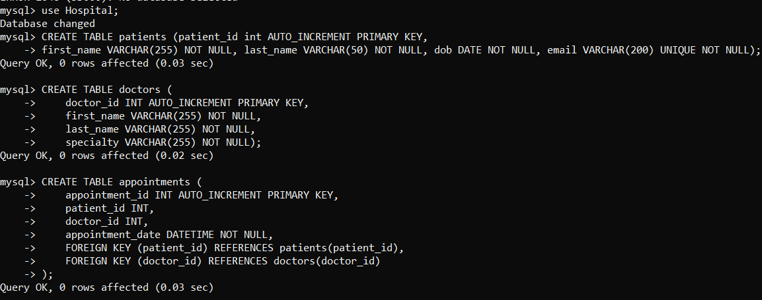

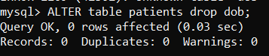

Inserted data

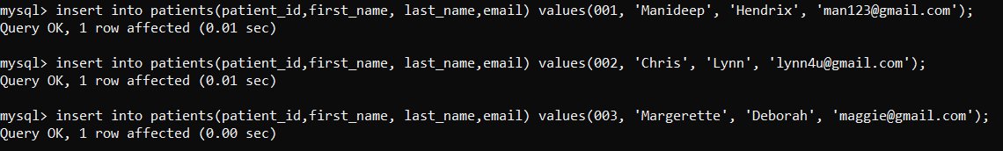

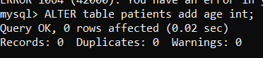

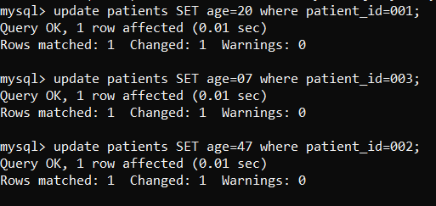

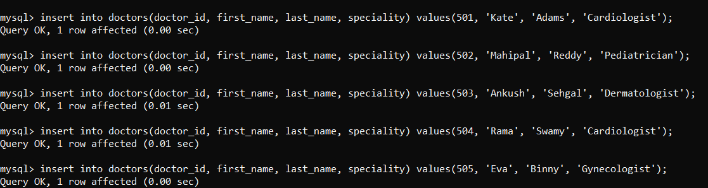

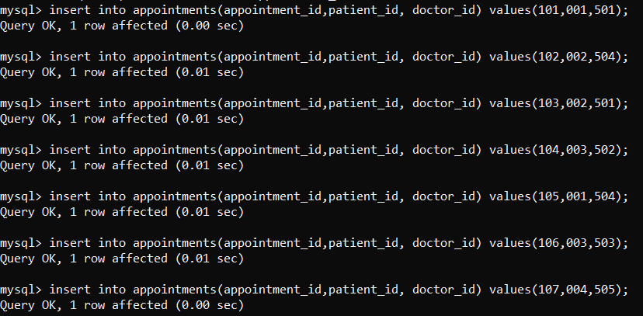

Patients Table

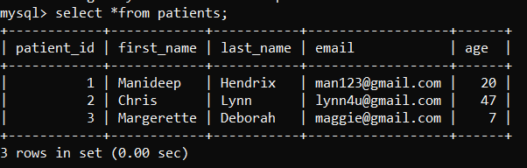

Doctors Table

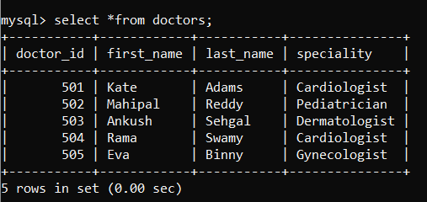

Appointments Table

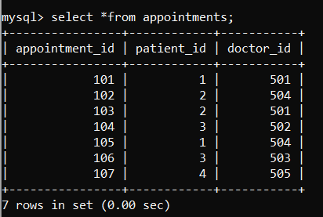

**2. Show primary, foreign and secondary keys from the relations.  
  
Primary keys –** uniquely identifies each record in table  
Here Patient_id, doctor_id, appointments_id are primary keys  
 **Foreign Keys** are patient_id, doctor_id

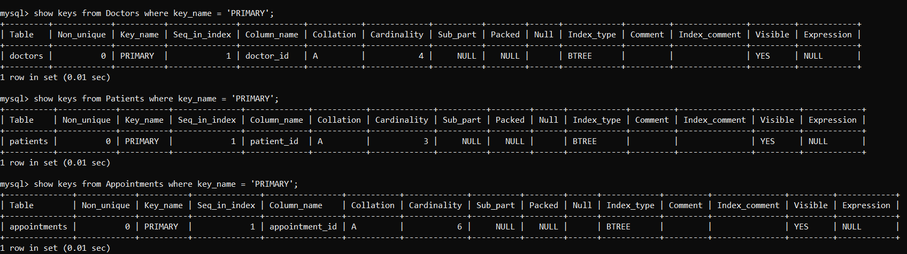  
  
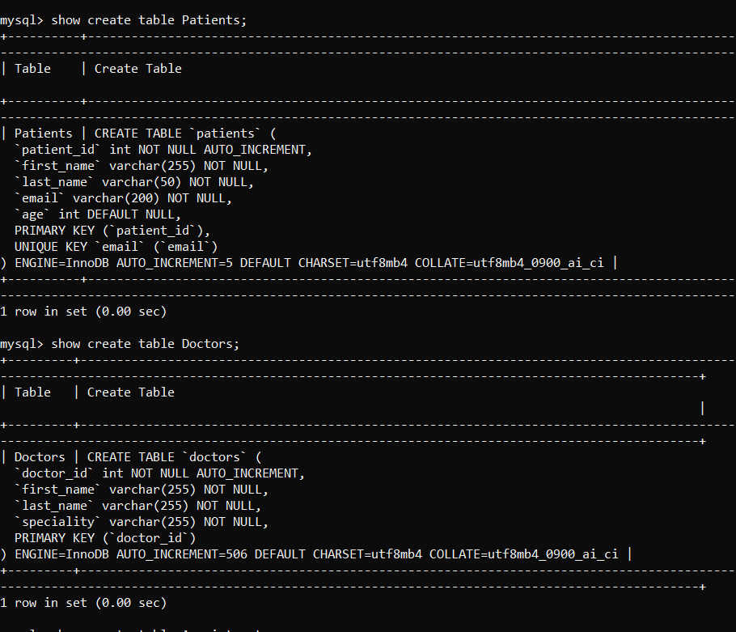

Foreign Keys

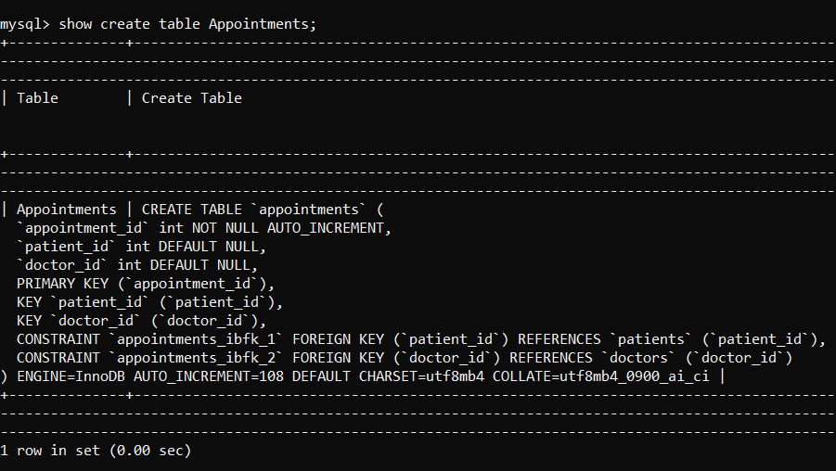

Secondary Keys

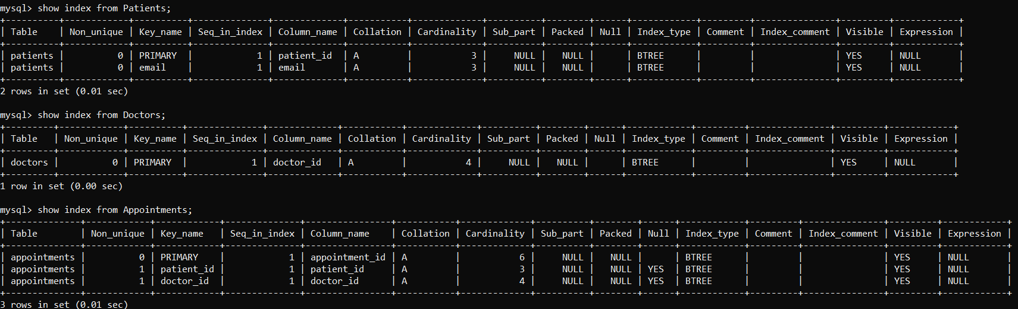

**3. Provide an example of a query where two relations are involved.**

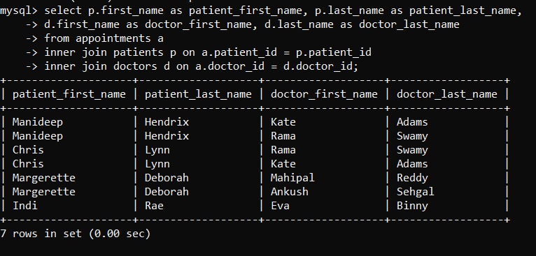

**4. Create new user and grant privileges for data manipulation**

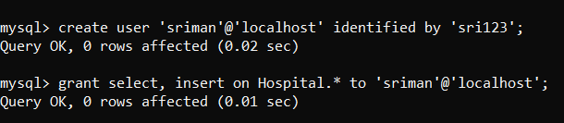

**5. Backup the database.**

